Identification of S-genotypes and a novel S-RNase in 84 native Chinese pear accessions
Author links open overlay panelMin He, Lufei Li, Ying Xu, Jianxin Mu, Zhihua Xie, Chao Gu, Shaoling Zhang
Show more
Add to Mendeley
Share
Cite
https://doi.org/10.1016/j.hpj.2022.02.002Get rights and content
Under a Creative Commons license
open access

Abstract
The Chinese pear (Pyrus spp.) exhibits typical gametophytic self-incompatibility (GSI), which inhibits self-crossing and promotes out-crossing, similar to other fruit species in the Rosaceae family. Thus, S-compatible cultivars are required in pear orchards to ensure successful pollination and stable yields. In this study, 84 native Chinese pear accessions were genotyped by allele-specific PCR using one pair allele consensus primers and 29 pairs of S-allele-specific primers that were designed in this study. After cloning and sequencing the PCR products, the S-genotypes of all 84 pear accessions, including wild and cultivated accessions, were determined. The reported 34 S-alleles and a novel S-allele were isolated from these pear accessions. These S-alleles were expressed specifically in the style. Sequence analysis identified that six pear cultivars originated in China shared the same S-RNases with P. communis (Pc). These findings supported the hypothesis that oriental and occidental Pyrus spp. may share the same pool of alleles at the S-locus. A novel S-RNase was isolated in ‘Putiandouli’, ‘Daguoshanli’, ‘Yunhongli 1′, and ‘Dianli’ and deposited as S67-RNase under accession number MT773568. Furthermore, the deduced amino acid sequences exhibited high similarity (99.56%) to S32-RNase in Malus. The high similarity between S-RNase in Pyrus and Malus indicated that the existence of S-RNase could have predated speciation between Pyrus and Malus. Furthermore, S-allele information was rearranged in Asian and European pears to provide information for selecting the best pollinator for widely cultivated pear cultivars in China. This information is useful for pear production, cross-breeding, and understanding the mechanism of the self-incompatibility reaction.
- Previous article in issue
- Next article in issue

Keywords
Pear
S-RNase
S-genotype
Parent assignment

1. Introduction
Pears are one of the most important fruit crops around the world and the third-most important fruit in China after apples and oranges (Zhang et al., 2019, 2021). Chinese pear (Pyrus spp.), belonging to the subfamily Malinae of Rosaceae, exhibits typical gametophytic self-incompatibility (GSI), which is determined by multiple alleles (S-alleles) at a single locus (S-locus) containing at least two genes. One is the stylar-S determinant that is determined by the S-RNase gene, while the other is the pollen-S determinant that may be controlled by one or multiple F-box genes (Sassa et al., 1992, 1997; Nettancourt, 1997; Ushijima et al., 2003; Okada et al., 2011; He et al., 2021).
Since the original identification of S-RNase alleles by cross-pollination experiments, pollen-tube growth assays, protein electrophoresis, PCR-RFLP (polymerase chain reaction-restriction fragment length polymorphism), PCR with gene-specific primer pairs, and gene chip hybridization, multiple S-RNase alleles have been identified from different Asian and European pear species (Hiratsuka et al., 1998; Sanzol, 2002; Heng et al., 2007, 2008b; Jiang et al., 2015a, 2015b). In recent years, over 100 Pyrus S-RNase genes have been submitted to the NCBI (National Center for Biotechnology Information) database, but their designation is confusing (Shi et al., 2018). The disordered designation in western and eastern pears was rearranged. In eastern pears, 68 alleles were finally integrated into 48 S-RNase alleles, numbered with Arabic numerals from S1 to S52 (Wang et al., 2017). In western pears, 19 S-RNase alleles were renumbered with Arabic numerals from S101 to S119 (Goldway et al., 2009). The identified S-genotypes of Pyrus spp. have been a useful reference for arranging suitable pollinators in pear orchards and selecting hybrid parents in breeding, thus avoiding a low fruit set ratio, bad quality, and failure in cross-breeding.
According to a previous study (Jiang et al., 2017; Zhang et al., 2018; He et al., 2021), there are at least six methods that can be used for pear S-genotype identification. In Japanese pear, PCR-RFLP was successfully used to identify several S-RNase alleles, including S1 to S7 and Sk, and their cDNA information has also been acquired by sequencing (Ishimizu et al., 1999; Castillo et al., 2002; Takasaki et al., 2004; Kim et al., 2007). In Chinese pears, PCR-RFLP, PCR amplification combined with DNA sequencing, and gene chip hybridization combined with DNA sequencing have been commonly used to identify S-RNase alleles from different Chinese pear accessions. Alleles from S11 to S66 have been identified (Heng et al., 2008a; Jiang et al., 2015a; Shi et al., 2018; Zhang et al., 2018). PCR-RFLP technology usually contains two steps: PCR amplification and PCR product digestion using each S allele-specific restriction endonuclease (Nashima et al., 2015). Although this method has advantages, such as reliability and speed, there are still disadvantages, such as complexity and cost. Recently, an S alleles-specific PCR system was established in apple (Long et al., 2010), Japanese pear (Nashima et al., 2015), European pear (Sanzol, 2009), and sweet cherry (Sonneveld et al., 2003). This method requires a suitable primer pair to be designed for each S-allele; subsequently, the PCR amplification product is separated by agarose gel to detect the target band. This system is potentially simple, fast, reliable, and economical to identify known S-RNase alleles. Due to the identification and cloning of an increasing number of pear S-RNase alleles, complete gene information is available on the NCBI database, thus providing the opportunity to design gene-specific primers for each S-RNase allele in Chinese pear. Therefore, an S allele-specific PCR system could be established to rapidly identify the S-genotypes in Chinese pear cultivars or accessions.
Although S-genotypes have been determined from pear accessions in the last two decades (Wang et al., 2017; Zhang et al., 2018), there are a large number of new pear varieties, and many wild accessions’ S-genotypes remain unclear. Furthermore, in the past several years, there have been several new S-RNase alleles and a complete sequence of identified S-RNase alleles that were isolated and cloned by different research groups. However, little is known about these S-RNase alleles, which could negatively affect both pollinator assignment and cross-breeding.
As the origin center of pear species, China has approximately 3 000 pear accessions, including P. pyrifolia (Pp), P. bretschneideri (Pb), P. sinkiangensis (Ps), and P. ussuriensis (Pu) (Cao and Zhang, 2020). Thus, to select the correct pollinator for pear production or cross breeding, the present study investigated the S-genotypes of 84 native Chinese pear cultivars using PCR methods combined with DNA sequencing. Then, based on this information, an S-allele-specific PCR system was established for rapidly identifying the S-genotype in Chinese pear accessions. A novel S-RNase (S67-RNase) was isolated from four native Chinese pear accessions. The high similarity of nucleotide sequences compared with Malus S32-RNase revealed a close relationship between S-RNases in Pyrus and Malus. To understand the relationship of S-RNase alleles between Asian pears and European pears, a new integration of S-RNase alleles was made in Asian and European Pyrus spp. that contained the latest S-RNase allele information. These results will be a good reference for pear orchard production and breeding.

2. Materials and methods

2.1. Materials
A total of 84 pear accessions, including 49 new pear varieties (P. pyrifolia, P. sinkiangensis, inter-specific hybrids) and 35 wild pear varieties (P. ussuriensis, P. pseudopashia, P. betulifolia, P. calleryana, and landraces), were maintained at Jiangpu orchard of Nanjing Agricultural University (Table S1). Young leaves of each pear accession were collected in the spring (May 2018). The root, stem, sepal, pollen, and styles of ‘Daguohuanghua’ were also collected from pre-blooming flowers. The fruit was collected 30 days after flowering. These materials were frozen in liquid nitrogen and then stored at–80 °C until use.

2.2. DNA and RNA extraction
Genomic DNA was extracted from young leaves of 84 native Chinese cultivars using the CTAB (cetyl trimethyl ammonium bromide) (Macklin, Shanghai, China) method. Total RNA from ‘Daguohuanghua’ was extracted from the root, stem, leaf, fruit, pollen, and style using an RNA prep Pure Plant Kit (Polysaccharides & Polyphenolics-rich) (Tiangen, Beijing, China), and first-strand cDNA was synthesized using a TransScript One Step gDNA Removal and cDNA synthesis Supermix (TransGen, Beijing, China) according to the manufacturer's instructions.

2.3. Gene-specific primers for each S allele
The principles for designing the specific primers were identical to those in previous studies using DNASTAR software (Promega) and Primer Premier 5.0 (Premier Biosoft International) (Long et al., 2010; Nashima et al., 2015). Pear accessions with a known S-genotype were regarded as controls and used to identify the appropriate conditions for each primer pair using a gradient PCR Veriti 96-Well Thermal Cycler (Thermo Fisher Scientific, MA, USA).

2.4. PCR amplification and sequence analysis of genomic S-RNases
PCR was performed with the consensus primers, forward primer (FP) (5′-TTTACGCAGCAATATCAGC-3′) and reverse primer (RP) (5′-AC(A/G)TTCGGCCAAATAATA-3′) (Ishimizu et al., 1999), and 29 pairs of specific primers to amplify the pear S-RNase alleles (Table 2) using genomic DNA as a template. The reaction system was as follows: 25 µL 2 × Taq Master Mix (Vazyme, Nanjing, China), 2 µL (5 µmol • L−1) upstream primer and 2 µL (5 µmol • L−1) downstream primer (Shanghai Sangon Biological Engineering and Technology Limited, Shanghai, China), 1 µL DNA (50 ng), and 20 µL RNase-free ddH2O, for a total volume of 50 µL.
Amplification was conducted in a Veriti 96-Well Thermal Cycler (Thermo Fisher Scientific, MA, USA) with the following amplification procedure: pre-denaturation at 95 °C for 5 min, denaturation at 95 °C for 15 s, annealing at the optimized temperature (Table 2) for 30 s, and extension at 72 °C for 2 min for 35 cycles, and final extension at 72 °C for 5 min. The products were separated by 2% (w/v) agarose gel in 1 × TAE buffer (Tris, acetic acid and EDTA). The target band was purified using a Vazyme Fast Pure Gel DNA Extraction Mini Kit (Vazyme, Nanjing, China) after agarose electrophoresis detection. The purified product was cloned into the pEASY®-Simple Cloning Vector (TransGen, Beijing, China), and recombinant vectors were transferred into E. coli DH5α (Vazyme, Nanjing, China). Positive clones were sequenced at least three times to confirm the correct sequences. The S-RNase allele information was determined using the BLASTN program at NCBI Genbank database (http://www.ncbi.nlm. nih.gov/BLAST).

2.5. RT-PCR analysis
RT-PCR was performed with the gene-specific primers for PpS2-RNase (AB014073.1), forward primer (5′- TTTACGCAGCAATATCAGC-3′) (Ishimizu et al., 1999) and reverse primer (5′-GCCAGAAGCCTCGATTAGCTT-3′) (Wu et al., 2007) to amplify the pear S2-RNase allele using cDNA from six different pear tissues (root, stem, leaf, fruit, pollen, and style) as a template. PbTUB, expressed in all tissue types, was used as a positive control gene that was amplified using a forward primer (5′-TGGGCTTTGCTCCTCTTAC-3′) and reverse primer (5′-TCAGTCGCCG CCGGCCTTTTG-3′) (Chen et al., 2015). The PCR reaction system and amplification procedure were identical to that in Section 2.4, except that the annealing temperature was changed to 60 °C. The PCR products were separated by 2% (w/v) agarose gel in 1 × TAE buffer.

2.6. Homologous cloning
To obtain the full-length sequences of the unknown S-RNase allele, homologous cloning was performed with allele-specific PCR amplification. The reverse primer (5′-CGCATCCTTAATACTGAATAC-3′) was designed based on the Malus S32-RNase allele sequence, and the forward primer (5′-TGCCTCGCTCTTGAACAAA-3′) was designed based on a conserved region upstream of the signal peptide of the Pyrus S-RNase allele. The PCR reaction system and amplification procedure were identical to that in Section 2.4, except that the annealing temperature was changed to 51 °C. PCR product purification and DNA sequencing were also identical to that in Section 2.4.

2.7. Acquirement of nucleotide sequence of different S-RNase alleles in Pyrus species
In addition to the accession numbers reported in other research, “Pyrus, S-RNase gene" was also used as a keyword to search the nucleotide sequences in the NCBI Genbank database. These nucleotide sequences were downloaded from GenBank, EMBL, and DDBJ databases. For each S-RNase allele, the longest sequences were acquired using BLAST in NCBI for homology analysis among Pyrus S-RNase genes in Vector NTI Version 11 (http://www.invitrogen.com) with the CLUSTAL W program (Wang et al., 2017).

2.8. Phylogenetic analysis of Pyrus S-RNase alleles
The amino acid sequences of Pyrus S-RNase alleles were downloaded from the GenBank database (https://www.ncbi.nlm.nih.gov/genbank/). The aligned amino acids constructing phylogenetic trees were identical to those in a previous study (Wang et al., 2017) by using BioEdit software version 7.1.11 (http://www.mbio.ncsu.edu/bioedit/bioedit.html) and MEGA version 6 (Tamura et al., 2013).

3. Results

3.1. Identification of S-RNase alleles in 84 Chinese pear accessions
A total of 84 Chinese pear cultivars and accessions were analyzed with the consensus primer pair, FP and RP. Except for 2–3 different fragments detected in 48 pear accessions (Fig. 1, A, B), only a single fragment was amplified from the remaining 36 accessions (Fig. 1, C). After sequencing the PCR product, 35 S-RNase alleles, including a novel S-RNase allele, were isolated from 84 pear accessions, and each pear accession had at least two different S-RNase alleles. Because the amplified fragments of two S-RNase alleles had similar size (less than 20 bp) in 36 accessions, only one target band was detected on the agarose gel (Table 1). Furthermore, to detect the expression level of S-RNase alleles in different pear tissues, RT-PCR was performed using cDNA from the roots, stems, leaves, fruit, pollen, and styles of Daguohuanghua. The amplification showed no target band in the roots, stems, leaves, fruit, or pollen; however, one target band was found in the styles. As a control gene, PbTUB was amplified in each pear tissue type (Fig. 2). This evidence indicated that S-RNase alleles were exclusively expressed in the style, which is consistent with a previous report (Shi et al., 2018). Among these pear accessions, S-genotypes of ‘Pingboxiang’ (S1S8), ‘Huanghua’ (S1S2) and ‘Daguohuanghua’ (S1S1S2S2) were the same as that determined in previous studies (Wu et al., 2007; Gong et al., 2011). But the nucleotide sequences of S8-RNase had little difference (Comparing with sequences of S8-RNase in present study), the base of the interval between S8-RNase C1 and C2 was mutated from A to G (Fig. S3). Meanwhile, the sequences of other S-alleles (S1-RNase, S2-RNase) were consistent with previous studies (Wu et al., 2007; Gong et al., 2011).
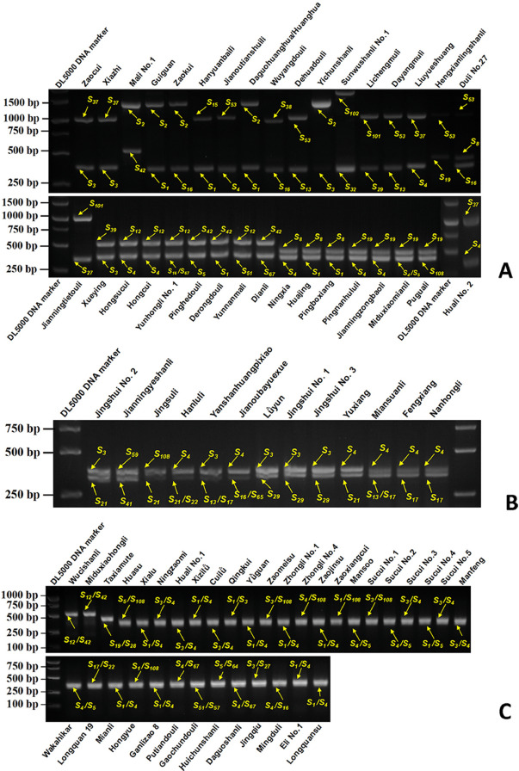
Download : Download high-res image (2MB)
Download : Download full-size image
Fig. 1. Identification of S-genotypes in 84 pear accessions
(A, B): 48 pear accessions or cultivars were analyzed with the consensus primer pair. PCR products were separated on 2% agarose gel. Each cultivar had at least two electrophoresis bands. The S-genotypes of these pear accessions or cultivars were marked above or below the electrophoresis band. (C): Because of the identical fragment sizes between the two different S-RNase alleles in one accession, there was only one target band in agarose gel for the remaining 36 pear accessions or cultivars. The S-genotypes of these pear accessions or cultivars were also marked above or below the electrophoresis band.
Table 1. Identification of S-genotypes in 84 pear accessions
Cultivar | PCR products/bp | S-genotype | Cultivar | PCR products/bp | S-genotype
1. Huasu | 376/369 | S5S108 | 43. Huanghua | 367/1347 | S1S2
2. Xialu | 367/368 | S1S4 | 44. Jingqiu | 376/352 | S3S7
3. Ningzaomi | 376/368 | S3S4 | 45. Jianou Tianshuili | 368/997 | S4S53
4. Ningxia | 368/434 | S4S8 | 46. Longquan 19 | 341/345 | S17S22
5. Huajing | 367/434 | S1S8 | 47. Hanyuanbaili | 367/989 | S1S15
6. Zaocui | 376/998 | S3S37 | 48. Miansuanli | 368/345/341 | S4S16S17
7. Eli 1 | 367/368 | S1S4 | 49. Mianli | 367/368 | S1S4
8. Yuxiang | 368/336 | S4S21 | 50. Miduxiaohongli | 536/529 | S12S42
9. Huali 2 | 368/998 | S4S37 | 51. Miduxiaomianli | 368/376/445 | S4S5S19
10. Jingshui 1 | 376/347 | S3S29 | 52. Pingnan Hululi | 368/445 | S4S19
11. Jingshui 2 | 376/336 | S3S21 | 53. Jianning Zongbaoli | 368/445 | S4S19
12. Jingshui 3 | 376/347 | S3S29 | 54. Puguali | 445/369 | S19S108
13. Xiazhi | 376/998 | S3S37 | 55. Jianning Tietouli | 352/998 | S27S101
14. Huali 1 | 376/368 | S3S4 | 56. Jianou Bayuexue | 368/345/338 | S4S16S65
15. Xueying | 376/528 | S3S39 | 57. Yanshanhuangpixiao | 376/350/341 | S3S13S17
16. Guiguan | 367/1347 | S1S2 | 58. Hengxian Lingshanli | 445/997 | S19S53
17. Fengxiang | 368/341 | S4S17 | 59. Liuyueshuang | 368/998 | S4S37
18. Xizilǜ | 367/368 | S1S4 | 60. Longquansu | 367/368 | S1S4
19. Cuilǜ | 376/368 | S3S4 | 61. Hanluli | 368/336/345 | S4S21S22
20. Lǜyun | 376/347 | S3S29 | 62. Hongyue | 367/369 | S1S108
21. Qingkui | 367/376 | S1S3 | 63. Ganlizao 8 | 367/368 | S1S4
22. Yuguan | 367/368 | S1S4 | 64. Mingduli | 368/345 | S4S16
23. Zaomeisu | 376/369 | S3S108 | 65. Duli 27 | 345/997 | S8S16S53
24. Zhongli 1 | 367/368 | S1S4 | 66. Putian Douli | 368/350 | S4S67
25. Zhongli 4 | 368/369 | S4S108 | 67. Pinghe Douli | 376/529 | S5S42
26. Hongsucui | 368/536 | S4S12 | 68. Wuyang Douli | 345/933 | S16S38
27. Hongcui | 368/536 | S4S12 | 69. Derong Douli | 367/529 | S1S42
28. Yunhongli 1 | 536/345/350 | S12S16S67 | 70. Gaochun Douli | 364/362 | S51S57
29. Zaojinsu | 367/368 | S1S4 | 71. Dehua Douli | 350/997 | S13S53
30. Jinsuli | 336/369 | S21S108 | 72. Jianning Yeshanli | 333/369 | S41S59
31. Pingboxiang | 367/434 | S1S8 | 73. Huichun Shanli | 376/353 | S5S64
32. Zaokui | 1347/345 | S2S16 | 74. Nanhongli | 368/341 | S4S17
33. Zaoxiangcui | 367/369 | S1S108 | 75. Yichun Shanli | 1347/376 | S2S3
34. Mansoo | 368/376 | S4S5 | 76. Daguoshanli | 368/350 | S4S67
35. Sucui 1 | 367/376 | S3S108 | 77. Sunwu Shanli 1 | 349/1413 | S32S102
36. Sucui 2 | 368/376 | S4S5 | 78. Wucishanli | 536/529 | S12S42
37. Sucui 3 | 376/368 | S3S4 | 79. Licheng Muli | 347/998 | S29 S101
38. Sucui 4 | 367/376 | S1S5 | 80. Dayang Muli | 350/997 | S13S53
39. Sucui 5 | 376/368 | S3S4 | 81. Yunnan Mali | 536/364 | S12S51
40. Manfeng | 376/368 | S3S4 | 82. Mali 1 | 1347/529 | S2S42
41. Wakahikari | 368/376 | S4S5 | 83. Dianli | 529/350 | S42S67
42. Daguohuanghua | 367/1347 | S1S2 | 84. Taxiamute | 445/427 | S19S28
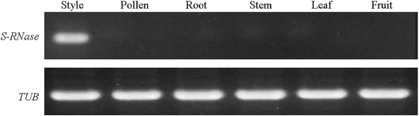
Download : Download high-res image (122KB)
Download : Download full-size image
Fig. 2. Expression of S-allele in different pear tissues

3.2. Analysis of S67-RNase complete sequence in Pyrus
A novel S-RNase allele was isolated from four pear accessions (‘Putiandouli’, ‘Daguoshanli’, ‘Yunhongli 1′, and ‘Dianli’) based on PCR methods. To acquire the complete sequence, a reverse primer was designed based on the homologous allele (Malus S32-RNase allele, MG598506.1) sequence, as well as a forward primer based on a conserved region upstream of the Pyrus S-RNase allele signal peptide (Fig. 3, C). An 866 bp fragment was cloned from the genomic DNA of ‘Putiandouli’, ‘Daguoshanli’, ‘Yunhongli 1′, and ‘Dianli’ (Fig. 3, D). S67-RNase contained 684 nucleotides, encoding 226 amino acid residues, and had a length of 156 bp intron. Alignment of the deduced amino acid residues of S67-RNase, together with isolated S-RNases of different Pyrus spp., indicated that S67-RNase had the same basic structure of Pyrus S-RNases, including two essential histidine residues for T2/S-type RNase activity, eight cysteine residues crucial for the tertiary structure, five conserved regions (C1, C2, C3, RC4, and C5), and one RHV region and intron (Fig. 3, A; Fig. S1).
Download : Download high-res image (2MB)
Download : Download full-size image
Fig. 3. Identification of the novel S67-RNase allele
(A): Alignment of deduced amino acid sequences for S67-RNase with S-alleles from S1-S9 in Pyrus. The putative signal peptide region, a hypervariable (HV) region, and the five conserved regions (C1, C2, C3, RC4, and C5) described for the Rosaceae (Ushijima et al., 1998) are underlined. Eight conserved cysteine residues and two histidine residues essential for RNase activity are marked with black and white circles, respectively. (B): Alignment of the deduced amino acid sequences and intron sequences of the S67-RNase and S32-RNase isolated from Pyrus and Malus. (C): Designed primers for homologous cloning of S67-RNase. (D): PCR amplification results of S67 -RNase from four different pear cultivars.
This information was consistent with a previous study (Ushijima et al., 1998), which demonstrated that S67-RNase was a novel S-RNase. After comparing the amino acid sequences between Pyrus S67-RNase and Malus S32-RNase, a very high similarity (99.56%) was observed, and there was only one amino acid difference that existed in the signal peptide region. In the intron region, only a 4-bp difference was found (Fig. 3, B), indicating that Pyrus S-RNase was very closely related to Malus S-RNase.

3.3. Sequence identity of S-RNase alleles in Asian and European pear
Although previous studies have integrated Asian and European pear populations (Wang et al., 2017), some allelic information remains incomplete. In the past several years, the gene information of 19 Asian and 11 European pear S-RNase alleles was submitted to the NCBI database (different colors in Fig. 4). Thus, a new integration was created to distinguish them. The results showed that some S-RNase alleles with an identical number had different deduced amino acid sequences (DAAS), such as S37-, S101-, and S107-RNase (marked with colored circles). S-RNase alleles from Asian pears had almost identical DAAS with European pears, such as PpS37-RNase versus PcS37-RNase, PuS37-RNase versus PcS101-RNase, PpS47-RNase versus PcS104-RNase, PpS48-RNase versus PcS106-RNase, PsS22-RNase versus PcS107-RNase, Pu/PbS35-RNase versus PcS108-RNase, PpS65-RNase versus PcS109-RNase, PpS66-RNase versus PcS114-RNase and PpS64-RNase versus PcS119-RNase (Table S2). In some Asian pear species, S-RNase alleles with different numbers shared extremely similar DAAS (Table S3), such as PpS6-RNase versus PpS54-RNase, PpS47-RNase versus PpS56-RNase, and PbS35/PuS35-RNase versus PpS59.1-RNase. These alleles with almost identical DAAS were integrated into the same branches and showed the highest bootstrap values in the phylogenetic tree (purple branches in Fig. 4). Meanwhile, there were still some S-RNase alleles between different Pyrus spp. that shared extremely similar nucleotide sequences (yellow branches in Fig. 4). According to a previous report (Wang et al., 2017), S-alleles with nearly identical DAAS could be regarded as the same S-alleles or homologous alleles. In the present study, 35 S-alleles were identified, and among these alleles, some alleles, such as PpS7-RNase versus PbS27-RNase, PuS37-RNase versus PcS101-RNase, PpS64-RNase versus PcS119-RNase, and PpS65-RNase versus PcS109-RNase, Pu/PbS35-RNase versus PcS108-RNase, had nearly identical DAAS. Theoretically, only 33 function-specific S-alleles were obtained in our study. These results provide a useful reference for following parent assignment between different pear species and designing allele-specific primers.
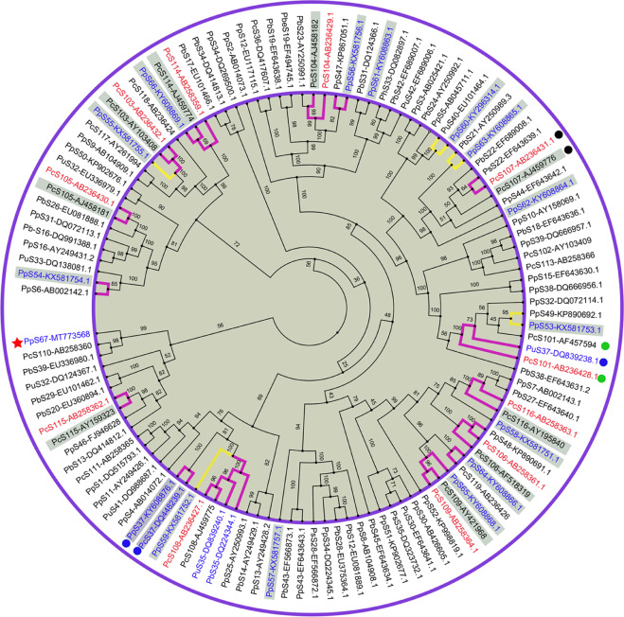
Download : Download high-res image (2MB)
Download : Download full-size image
Fig. 4. Phylogenetic tree of S-RNase alleles in the Asian and European Pyrus species
Circles with the same color represent the S-RNase alleles with the same number and have different nucleotide sequences. 19 Asian and 11 European pear S-RNase alleles are highlighted by blue and red color. Moreover, purple and yellow branches represent the corresponding S-RNase alleles that shared an almost identical and extremely similar nucleotide sequences, respectively. Gray backgrounds indicate the S-RNase alleles with partial sequence. The novel S-RNase allele was highlighted by red star.

3.4. Parent assignment for 36 main cultivars in China
As shown in Table S4, 84 pears were divided into two groups. One was completely incompatible, and the other was semi-compatible. These pears should be avoided because they are not good pollinators or acceptors of one another. Furthermore, cross-incompatiblity/compatibility was analyzed between 31 pear varieties (removing cultivars with identical S-RNase alleles and some wild pear accessions) and 36 main cultivars in China. The results showed that most pairs of these cultivars could be cross-pollinated reciprocally; only a few exhibited cross-incompatibility, including ‘Ningzaomi’ versus ‘Whangkeumbae’, ‘Cuyu’ and ‘Shinseiki’, ‘Zaocui’ versus ‘Weiningdahuangli’, ‘Hongcui’ versus ‘Meirensu’, ‘Zhongli 4′ versus ‘Zhongli 1′, and ‘Guiguan’ and ‘Huanghua’ (Fig. 5). Therefore, these cultivars should be excluded from pear orchard production and cross-breeding. For the remaining semi-compatible pairs of these cultivars, they should not be reciprocally selected as pollinators or acceptors for breeding new pear varieties, but they could be selected for pear orchard production. Therefore, completely compatible cultivars would be the best choice in both pear breeding and production.
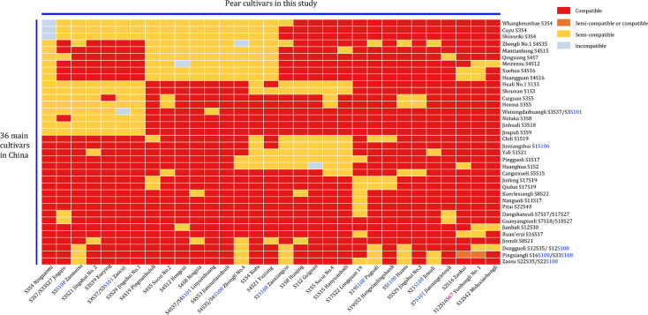
Download : Download high-res image (953KB)
Download : Download full-size image
Fig. 5. Heatmap representing cross-(in)compatibility between the different pear cultivars in China
The European pear S-alleles and their corresponding cultivars were highlighted by blue color. The novel S-RNase was highlighted by purple color.

3.5. Designing of allele-specific primers for 29 S-alleles in Chinese pears
The nucleotide sequences of the identified S-RNase alleles were downloaded from the NCBI and DDBJ databases, and the nucleotide sequences of S67-RNase (MT773568) were obtained in this study. Because the sequences of S53-RNase (KX581753.1) and S59-RNase (KX581752.1) were too short to design suitable primer pairs, this allele, together with the European pear S102-RNase, were not presented in this study. The nucleotide sequences of 29 S-alleles were aligned to select the specific primer pairs for each S-RNase allele. Because of the high similarity between some S-alleles, several primer pairs were designed, and for each primer pair, a specific sequence of 3 bp from the 3′ end was presented in at least one primer to maintain specificity. Furthermore, the annealing temperatures of whole allele primer pairs were determined using gradient PCR. The genotyped cultivars in this study were used as a control to select appropriate primer pairs. Overall, 29 pairs of allele-specific primers were identified (Table 2), and their amplification products were separated by 2% agarose gel (Fig. 6). As shown in Fig. 7, each allele-specific primer pair showed different genomic DNA positions (calculated from the first base of the longest acquired nucleotide sequence). Among them, except for S5- and S29-RNase, the remaining allele-specific PCR products contained introns (whole or part). Presently, the complete nucleotide sequences of S41-, S57-, S64-, and S65-RNase are unknown, and the consensus primer RP was used for the amplification of S57-RNase. The specific primer pairs of S64- and S65-RNase were designed based on their homologous alleles S119- and S109-RNase, respectively. The specific primer pair of S41-RNase was designed based on the identical sequence of the P. betulifolia S2 allele (KC465908.1)
Table 2. Characteristics of each S-RNase allele-specific primer pair in self-incompatible pear
S-allele | GenBank No. | Primer pairs | Sequence (5′–3′) | Size of PCR Products/bp | Annealing temperature/ °C | Genomic DNA position
S1 | AB002139.1 | PpS1-SpF  PpS1-SpR | AATGGACCTGACCCAGAAAAATG  ACACTGGAGGGGCAGGAAAATCG | 643 | 56 | 217–239  671–692
S2 | AB014073.1 | PpS2-SpF  PpS2-SpR | GCAAGACAAAGAGATATCGGAAG  TTTCCAACTGGGGTTCGAGTC | 1204 | 57 | 823–845  2006–2026
S3 | AB025421.1 | PpS3-SpF  PpS3-SpR | TGGCCTTCAAACATGGTAGGACCTG  TCTACACACGAATCCATGTGGCACG | 966 | 58 | 3032–3056  3972–3997
S4 | AB009385.1 | PpS4-SpF  PpS4-SpR | ATCCGCACCACCACCTATACTAC  AATACTTAACATTGGCGGGGCAG | 944 | 55 | 1341–1363  2262–2284
S5 | AB045711.1 | PpS5-SpF  PpS5-SpR | CGATCGAACCAAAAATAAACTCTTC  TAAGTCATTTTCCTAGCTTTTACGG | 743 | 53 | 1123–1147  1841–1865
S7/S27 | EF643640.1 | PpS7-SpF  PpS7-SpR | TGCACTAATGCAACCGTGAATC  GCACCAGTGGCCTTTGTATTCC | 423 | 53 | 251–372  652–673
S8 | AB104908.1 | PpS8-SpF  PpS8-SpR | TTGATAATCAGATTGTTAATATTGTTAGA  TGTTGTCCCATTCGGTTTAATATTCGC | 462 | 52 | 256–279  691–717
S12 | EU117115.1 | PpS12-SpF  PpS12-SpR | ACCAAATTATGTGTCACAATGGA  GAACTGCGTTAAGTTGCTATTGC | 608 | 55 | 357–379  942–965
S13 | AY249428.2 | PpS13-SpF  PpS13-SpR | TGGAACTTACCCGACCCAATCT  CTAGTATTCTTTTGGCACTTGAA | 515 | 52 | 227–248  719–741
S15 | EF643630.1 | PpS15-SpF  PpS15-SpR | TTGCTGACGTGCATCCAATTTGG  ATACTGGATATCTTTGATGGGGC | 1002 | 53 | 500–522  1479–1501
S16 | EF643635.1 | PbS16-SpF  PbS16-SpR | CAGCACAGGAAATGACCCCAT  CAATTCAGTCCTCTTAGTATTG | 524 | 54 | 226–246  728–749
S17 | EU101466.1 | PbS17-SpF  PbS17-SpR | TGGAATGGATCCCACCCAGTAA  AATGTGGTGATCCTTGTGGGAAT | 600 | 55 | 227–248  804–826
S19 | EF643638.1 | PbS19-SpF  PbS19-SpR | ATCCACATCATTTGATGAAGCC  CAATATCCACCAGTGTCCTGT | 333 | 51 | 437–458  749–769
S21 | AY250989.3 | PbS21-SpF  PbS21-SpR | ACTAATATTGTCTTCGTCCACGG  TATTGTGGGTACCGTTGCGTAT | 612 | 53 | 82–104  672–693
S22 | EF643639.1 | PsS22-SpF  PsS22-SpR | AGATAAGGAATCCTCGGAAG  GCGCTCTGCTTTTCCCGTCC | 406 | 57 | 255–274  641–660
S28 | KX214124.1 | PsS28-SpF  PsS28-SpR | TATTATTGATAATCAGATATTGTTAGA  TGGATATCTGTCAGTGCCTTG | 471 | 53 | 345–371  795–815
S29 | EU101462.1 | PbS29-SpF  PbS29-SpR | TTGGCCTTCTGGAATAAACAGT  GATTGTGAGCCATATGGGTGAC | 335 | 52 | 491–512  804–825
S32 | EU336979.1 | PuS32-SpF  PuS32-SpR | TATTGTCTTCGTCCGCGGCGA  CAACCAATTCAGTCACCTGGTT | 671 | 55 | 99–119  748–769
S35/S108 | DQ839240.1 | PuS35-SpF  PuS35-SpR | GAAAAATGCAAGAATATACAAATG  GAACTTCGTTAAGTCTCTATCACT | 574 | 50 | 249–272  799–822
S37/S101 | DQ839238.1 | PuS37-SpF  PuS37-SpR | TGTTCGTATGTATTTGATCTA  CTGACCTCGACCAATTCAATAG | 581 | 50 | 871–891  1430–1451
S38 | EF643631.2 | PbS38-SpF  PbS38-SpR | GCTACTATGAAACTCACTGACGG  GAGATTGATATCTTTGATGGGGCA | 854 | 55 | 594–616  1424–1447
S39 | EU336980.1 | PbS39-SpF  PbS39-SpR | GACCCTAAGCCAACAATGCTCT  TGGTGATGGTGGTTGAATTAGATT | 632 | 53 | 379–400  987–1010
S41 | DQ988687.1 | PuS41-SpF  PuS41-SpR | TCCTCTGCGCTTGTGTATAC  TGGGGGCAGTTTATGAACTTC | 509 | 52 | 164–183  652–672
S42 | EF689006.1 | PuS42-SpF  PuS42-SpR | TGTCTGCAATTTTAGTTCTAC  CGCCTTATTGTTGGTACCAC | 744 | 51 | 147–168  872–891
S51 | KP902677.1 | PpS51-SpF  PpS51-SpR | TCCATCAAACGTGACTTCTCA  CAGCATCCTGATTATCCCCT | 424 | 52 | 255–276  660–679
S57 | KX581757.1 | PpS57-SpF  PpS57-SpR | CGAATACAACCGTGAATCCTCTG  ACGTTCGGCCAAATAATT | 216 | 53 | 131–153  329–346
S64/S119 | KY608866.1 | PpS119-SpF  PpS119-SpR | TCAGCCAGCTGTCTGCTACTTTAAT  TCAACCAATTTAGTCACCTTATT | 624 | 52 | 246–270  847–869
S65/S109 | KY608868.1 | PpS109-SpF  PpS109-SpR | TTTGAATGGACCTCACCCAGC  CTACCAGTGGCCTTTTCAAC | 434 | 53 | 242–262  656–676
S67 | MT773568 | PpS67-SpF  PpS67-SpR | TTAGGGCCTGACCCAGAGTA  CTCAATTAGGTTGGGGCAATCTA | 591 | 53 | 230–249  798–820
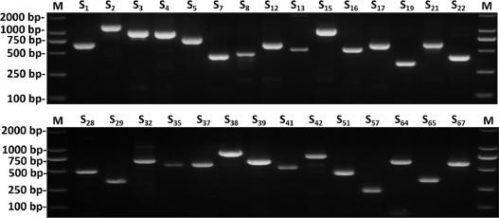
Download : Download high-res image (215KB)
Download : Download full-size image
Fig. 6. Genomic DNA amplication results by using 29 pairs of S-alleles specific primers
M. DL2000 DNA marker. Each lane shows the result of a single S-RNase allele specific PCR amplication using the cultivars genotyped in this study. PCR products were separated on a 2% agarose gel.
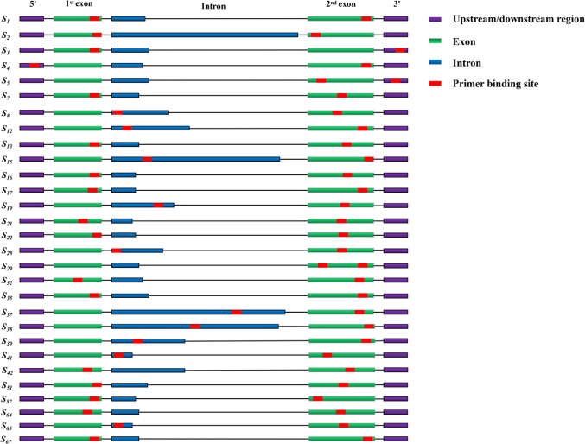
Download : Download high-res image (530KB)
Download : Download full-size image
Fig. 7. The binding site of designed primers specific for 29 S-RNase alleles
Green boxes show the conserved region of the S-RNase gene, dark purple boxes show the upstream/downstream region of the first exon/second exon, and dark blue boxes show the intron. Primer binding sites are indicated by a red box.

3.6. Rapid identification of S-genotypes of 84 genotyped pear cultivars
To test the specificity of the allele-specific primers, genomic DNA from 84 genotyped pear cultivars was used as a PCR amplification template to amplify the S-RNase allele with each specific primer pair. Then, PCR products were separated by 1% agarose gel. The results were presented using a subset of pear cultivars (18 pear cultivars containing all 29 S-alleles). Each pear cultivar contained the target band, and the fragment length was consistent with the expected amplification results (Fig. 8). The expected S-RNase allele combinations of 84 pear cultivars were the same as our results based on PCR methods combined with DNA sequencing. These results further demonstrated that S-genotypes of these 84 pear varieties are accurate. Thus, this gene-specific primer could be used for the rapid identification of the S-genotype in Chinese pear cultivars. According to a previous report (Long et al., 2010), for all 84 cultivars, a 96-aperture PCR apparatus could be used to detect a single S-allele in one PCR round. In total, 29 PCR rounds were required to identify the S-genotypes of all 84 cultivars.
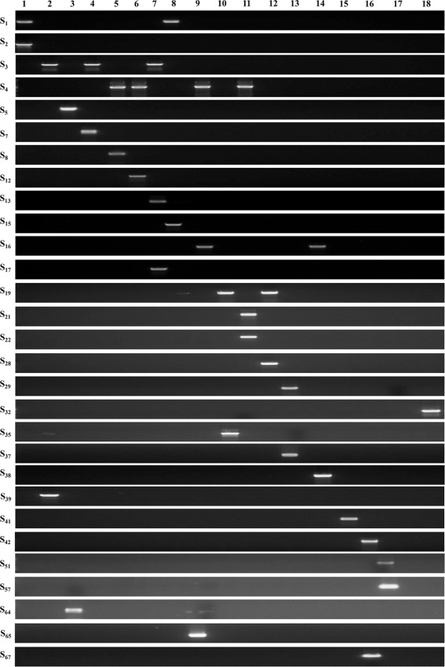
Download : Download high-res image (842KB)
Download : Download full-size image
Fig. 8. PCR amplification of S-alleles in a subset of pear cultivars using 29 S-alleles specific primer pairs
Each row shows the product of a single allele-specific PCR amplication using the different pear cultivars. 1: ‘Daguohuanghua’ (S1S2); 2: ‘Xueying’ (S3S39); 3: ‘Huichunshanli’ (S5S64); 4: ‘Jingqiu’ (S3S7); 5: ‘Ningxia’ (S4S8); 6: ‘Hongcui’ (S4S12); 7: ‘Yanshanhuangpixiao’ (S3S13S17); 8: ‘Hanyuanbaili’ (S1S15); 9: ‘Jianouba Yuexue’ (S4S16S65); 10: ‘Puguali’ (S19S35/S19S108); 11: ‘Hanluli’ (S4S21S22); 12: ‘Taxiamute’ (S19S28); 13: ‘Lichengmuli’ (S29S37/S29S101); 14: ‘Wuyangdouli’ (S16S38); 15: ‘Jianning Yeshanli’ (S41S59); 16: ‘Dianli’ (S42S67); 17: ‘Gaochundouli’ (S51S57); 18: ‘Sunwushanli 1′ (S32S102).

4. Discussion
Pears, one of the most important fruit crops in China, present a typical GSI, which inhibits self-crossing and promotes out-crossing, similar to other fruit species in the Rosaceae family. Under normal circumstances, in pear orchards, at least two different cultivars containing different S-RNase alleles should be cultivated to avoid low fruit set. Therefore, it is essential to select suitable pollinators for pear production and breeding. In this study, the S-genotypes of 84 Chinese pear cultivars or accessions were determined using PCR methods. Thirty-four reported S-alleles and a novel S-allele were isolated from the cultivars, and each cultivar had at least two different S-alleles. Among them, the complete gene information of some alleles was nearly perfect, while others were not. In the past several years, several new S-RNase alleles have been identified and the complete sequences of identified S-RNase alleles were isolated and cloned. However, little is known about these S-RNase alleles, causing some uncertainties for pollinator assignments. Furthermore, a previous report indicated that good pollinators should contain the following four aspects: 1) pollinators should provide enough pollen; 2) compared with acceptors, they should contain at least two different S-RNase alleles; 3) these S-RNase alleles should have low identities in amino acid sequences with acceptors (Wang et al., 2017). Although there are approximately 3 000 pear accessions in China, only 36 cultivars are widely cultivated. Of the genotyped Chinese pear accessions in this study, 84 were semi-compatible or completely compatible with the 36 primary cultivars used in China, indicating that they are good pollinators for one another. A novel S-RNase allele (S67-RNase) was isolated from four native Chinese pear accessions and showed a high similarity with Malus S32-RNase, supporting the hypothesis that the existence of S-RNases predated speciation between Pyrus and Malus. Some native Chinese cultivars, such as ‘Lichengmuli’ (P. xerophila), ‘Sunwushanli 1′ (P. ussuriensis), ‘Huichunshanli’ (P. ussuriensis), ‘Jianoubayuexue’ (landrace), ‘Puguali’ (landrace), and ‘Jianningtietouli’ (landrace), share some S-alleles with European cultivars. This was consistent with a previous report (Heng et al., 2008a) and further demonstrated that S-RNases of Pyrus spp. might share the same pool of alleles at the S-locus; the process of S-RNase evolution and speciation in Pyrus could be independent.
As for remaining Chinese cultivars that contain S108-RNase, these Chinese cultivars shared the same parent ‘Zaosu’ (S1S108/S1S35) that is a hybrid between ‘Pinguoli’ (S1S17) (P. bretschneideri) and ‘Mishirazu’ (S5S108) (Kimura et al., 2003). Mishirazu was imported from Japan; its parents are unknown, and it is regarded as a hybrid between P. pyrifolia and P. communis (Kimura et al., 2003). According to the phylogenetic tree in this study, Pu/PbS35-RNase, and PcS108-RNase were integrated into the same branch, showing the highest bootstrap value. Coincidentally, these two genes were all cloned from ‘Zaosu’. Furthermore, the allele-specific PCR product of S35-RNase was sequenced, and exhibited an extremely high identity with S108-RNase (Fig. S2). This information indicated that S35-RNase and S108-RNase had a high similarity and were perhaps same S-RNase allele. These explained why these Chinese pear cultivars contain S-genotypes of P. communis, and also offered a reasonable explanation for the puzzling designation between some Asian and European pear S-RNase alleles. In addition, among the 84 cultivars, S-RNase alleles from native Chinese P. pyrifolia could share some S-alleles with other Pyrus spp., including S-RNase alleles from Japanese pears, European pears, and other ancient pear species, implying that P. pyrifolia may be the common ancestor of other Pyrus spp. Some S-RNases, such as PpS1-, PpS3-, PpS4, and PpS5-RNase, had a high occurrence. This may be the result of these S-RNases having a close relationship with good traits or conferring adaptation to local environmental conditions (Heng et al., 2008a).
The self-incompatibility or compatibility of the 84 pear cultivars were not determined in this study. However, a previous report demonstrated that ‘Pingboxiang’ (S1S8) was self-compatible (Gong et al., 2011). DNA sequencing of the S8-RNase allele revealed that the base of the interval between S-RNase C1 and C2 was mutated from A to G, and that the amino acid sequence of the corresponding site was mutated from Aspartic acid to Glycine. This could have some relationship with the breakdown of self-incompatibility (Gong et al., 2011). In the present study, the S-genotype of ‘Pingboxiang’ was the same as that determined in a previous study (Gong et al., 2011), but sequence analysis of the S8-RNase allele indicated that there was no mutation between C1 and C2 (Fig. S3). Therefore, the breakdown of SI in the pear cultivar ‘Pingboxiang’ warrants further study.
Based on all allelic information, new integration was made for the S-RNase alleles of Asian and European pear species. The results showed that, as a previous study described (Wang et al., 2017), some chaotic designation still existed in new S-RNase alleles among some Asian and European pear species containing the following aspects: different S-RNase alleles shared extremely high identity and the same S-RNase allele number shared different nucleotides. For example, amino acid sequences of three S-RNases in European pear species (PcS101-, PcS106-, PcS107-RNase) were not consistent with previous reports (Goldway et al., 2009; Fig. S4). These variations were most likely introduced experimentally during PCR, by sequencing procedures (Quinet et al., 2014), or by inconsistent naming rules from different research institutes. Because the complete DNA sequence of some S-RNase alleles was not determined, it was unclear whether these alleles, which shared extremely high identity, could show the same recognition specificity with each other. These undoubtedly could cause some barriers when cross-breeding occurs between Asian or European Pyrus spp. Further study should be devoted to establishing suitable naming rules for these identical Pyrus S-RNase alleles in Asian and European Pyrus spp., in addition to exploring the recognition specificity in these alleles.
Except for these S-RNase alleles, there were still some S-RNase alleles between different Pyrus spp. that shared extremely similar nucleotide sequences. Cultivars with these S-RNase alleles should not be used as pollinators or acceptors together. The 84 genotyped cultivars in this study were used as controls to evaluate the specificity of the designed 29 pairs of allele-specific primers. The results demonstrated that these primers could be used to identify the S-genotypes of Chinese pear cultivars. The annealing temperature of each primer pair was between 50 °C and 58 °C. In fact, as a previous study reported (Nashima et al., 2015), when annealing at a low or high temperature, some minor bands or weak bands were found in some S-RNase alleles; therefore, 55 °C was the best choice.
To avoid unnecessary amplification, in the first PCR round, S-RNase allele consensus primer pairs were used to distinguish S-RNase alleles that had an obvious gap in the intron. Then, according to the different sizes of bands, corresponding allele-specific primers were selected. If there were no target bands in the agarose gel, a PCR method combined with DNA sequencing was needed to isolate the unknown S-RNase alleles. Thus, a rapid, economic, and reliable system was established for identifying Chinese pear S-genotypes.

5. Conclusions
In this study, S-genotypes of 84 Chinese pear accessions were identified based on PCR methods. A total of 34 S-RNase alleles and a novel S-RNase were isolated from these pear accessions, and each accession had at least two different S-RNase alleles. Some European pear S-RNase alleles shared extremely similar nucleotide sequences with Chinese pear species but shared different numbers and are potentially the same gene. This information will provide a useful reference for both better pollinator assignment and breeding of new varieties in Pyrus spp. By using the genotyped 84 pear cultivars, 29 pairs of S-alleles specific primers were designed and a rapid and reliable system was established to identify S-genotypes from Chinese pear cultivars. This method will significantly expedite the process of identification of S-genotypes in Chinese pear species.

Acknowledgments
We thank Professor Xiaogang Li from Jiangsu Academy of Agricultural Sciences for providing young leaves of some pear accessions. This work was financially supported by the National Natural Science Foundation of China (Grant No. 32172511), A Project Funded by the Priority Academic Program Development of Jiangsu Higher Education Institutions, and the Key Project of New Variety Breeding of Agriculture of Jiangsu Province (Grant No. PZCZ201725).

Appendix. Supplementary materials

